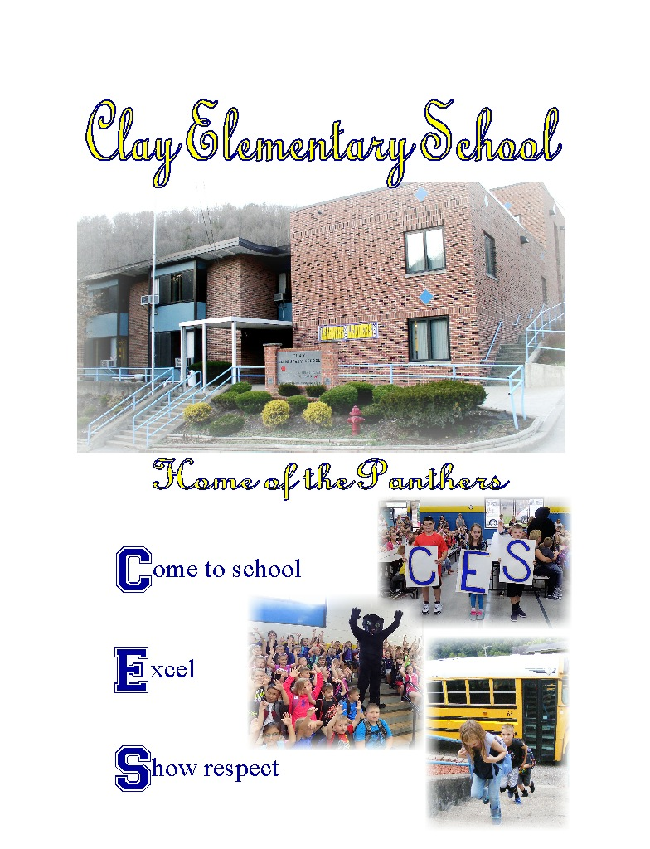
Clay Elementary School
Panthers
Michelle Paxton Mistie Legg Megan Starcher
Principal Assistant Principal Curriculum Specialist
Kelly Hamrick Felisha Nutter
Secretary School Psychologist
P.O. Box 600 219 Church Street Clay, West Virginia
25043

Telephone: (304)587-4276
Fax: (304)587-4279

Clay County Board of Education
Mr. Joe Paxton, Superintendent
Mrs. Joan Haynie, Assistant Superintendent
Mr. Jared Fitzwater, Director of Student Services
Mrs. Tina Burnette, Administrative Assistant
Mr. Eric Legg, Director of Special Education
Mr. David Pierson
Mrs. Susan Bodkins
Mrs. Brooke Jones
Mrs. Phoebe Nichols
Mrs. Lolita Nutter

Business Partners
Clay County Bank Pierson Lumber Co. Bernardo Dentistry John G. Hubbard DDS Wilson Shamblin Smith Funeral Home
SCHOOL MISSION
Come to School - Excel - Show Respect
SCHOOL GOALS
Increase Student Academic Achievement
Increase Student Attendance
Increase Student Engagement

ATTENDANCE/ ABSENCES
West Virginia law requires attendance at school for children between the ages of six and sixteen. Student absences will be excused for the following reasons:
A. Illness or injury of the student
B. Medical or dental appointment
C. Illness or injury in family and student’s presence is deemed essential by physician
D. Calamity, such as fire in the home, flood, or family emergency
E. Death in the family. (Limit: 3 days except extraordinary circumstances)
* Parents may provide written verification for an absence due to illness or injury for no more than five days per semester for a total of ten days in a given year. Parental excuses may not exceed three consecutive days. A doctor’s excuse will also be required for any absences over the ten parental excuses. Please keep in mind that an excused absence is still an absence and therefore will count against perfect attendance status. Excuses must be presented directly upon return to school. Days missed because of suspension from school will count as absences. Reminders for unexcused absences will be sent from the school. The Communities in Schools Coordinator will have meaningful contact with the parents/guardians after three and five unexcused absences. After your child accumulates ten (10) unexcused absences, a written notice will be sent from the county Attendance Director to parents/guardians. If unexcused absences continue after ten days, the case will be referred to the Clay County court system for legal action. Please keep in mind that an excused absence is still an absence and therefore will count against perfect attendance status for rewards.

STUDENT CODE OF CONDUCT
In order for every student to have the opportunity to reach his/her potential, every student in the public schools of West Virginia shall:
1. Attend school faithfully, complete all assignments on time, and work to his/her full potential
2. Behave in a manner that does not disrupt classroom learning or the operation of the school
3. Obey teachers, principals, and others in authority
4. Refrain from any intimidating, aggressive, or threatening behavior toward fellow students, teachers, or other school staff
5. Refrain from the possession or use of any weapons, illegal drugs, alcohol, or tobacco products

ORDERLY ATMOSPHERE
The following rules have been established to provide an atmosphere that is conducive to learning.
Classroom Rules:
1. Come to class prepared
2. Do not leave your seat without permission
3. Raise your hand to ask or answer questions
4. Follow directions the first time given
5. Keep hands, feet, and objects to yourself.
Hallway/Cafeteria Rules:
1. Walk, don’t run
2. Talk quietly
3. Use single file on right side of hall
4. No pushing or shoving
5. Follow directions the first time given
6. Put trash in proper cans
7. Do not throw or play with food
Restroom Rules:
1. Talk quietly
2. Do not write or mark on wall/floor
3. Only two at a sink or one in a stall
4. Put used towels in trash containers
5. No playing or loitering
EARLY ARRIVAL AT SCHOOL
Parents/Guardians are permitted to drop off students at 7:30 a.m. Please do not drop off students before this time. The school is not responsible for students who arrive before 7:30 a.m. Students should be off school grounds by 3:30 p.m. unless participating in an extracurricular activity under adult or teacher supervision.

LATE ARRIVAL/EARLY DEPARTURE
Parents who plan to meet or pick up students during regular school hours must come to the office to do so. Individuals on student sign out sheets may sign a student out. All students must sign out in the office when leaving campus and sign back in upon return or when arriving late.
DELAYS, CANCELLATIONS AND EMERGENCY EARLY DISMISSALS
School delays, cancellations, and emergency early dismissals are broadcast over local radio and TV stations. Sarah the School Messenger will call each student’s home. Dismissal information can also be found on the Internet at this URL: www.claycountyschools.org
Parents should make arrangements for children to have an alternative location to go in case of an early dismissal if parents will not be home. Please provide your child’s teacher with the name, address, and phone number of a person who can be responsible for them in the event of an emergency dismissal.
BUS PASSES
Students who may need to ride a different bus may do so only if their parent or guardian sends a note to school to make this request. Phone calls will be accepted only in an emergency situation. The note should state the name of the child, the date, the bus number that the child will be riding, the drivers name if known, and the name of the person who will be there to take care of the child.
Notes should be given to homeroom teachers before 8:10.
VISITORS
Visitors with legitimate school business must register in the office and have a visitors pass. Visitors must leave promptly when business is finished.
Guests are welcome to visit with an administrator at any time during school hours. However, it is best to make an appointment to make sure we are available.
Conferences with teachers should be arranged by appointment during the teacher’s planning period.
To avoid distractions, and for matters of safety, you will need special permission to visit any classroom or be in our hallways. Visitors should enter the school through the main entrance on Church Street.
TELEPHONE USE
Telephones in the school office are only for official business. Students may use the office phones only for emergency calls. Permission must be obtained before phones are used.
DRESS CODE
Students are expected to dress appropriately every day. Students are strictly forbidden from wearing clothing or items that refer to alcohol, drugs, or tobacco; contain profane or abusive language, or have sexual or vulgar implications.
We will not allow dress that distracts from the educational process or poses a safety risk. Platform shoes, flip flops, short shorts, halter tops, tops that reveal belly buttons, large muscle shirts, see-through shirts, or any other distracting clothing may not be worn. Pants may not hang on students hips. Any violation of this code must be corrected before a student may attend class.

BULLYING/ HARRASSMENT Bullying, harassment, and/or intimidation may be defined as any intentional gesture, or any written, verbal, or physical act, or threat that is sufficiently inappropriate, severe, persistent, or pervasive that it creates an intimidating, threatening, or abusive education environment.
Bullying is also an act or gesture that a reasonable person under the circumstances should know will have the effect of harming a student or creating a reasonable fear of being harmed, damaging a student’s property, or creating a reasonable fear of property damage.
Bullying will not be tolerated at Clay Elementary School. A student who believes he or she has been the victim of any form of bullying, harassment, or intimidations shall report the alleged acts to the supervising adult. Any staff member having knowledge or reasonable belief of conduct which may constitute any form of bullying, harassment, or intimidation toward a student shall report the alleged acts immediately to the building Administrators. The Administrators shall become the designated investigator. If the results of the investigation support disciplinary action, appropriate disciplinary action may include: warning, written reprimand, suspension, exclusion, expulsion and/or termination. Disciplinary action will be determined at the discretion of the designated investigator.

HOMEWORK
Teachers at Clay Elementary will assign homework with two goals in mind: Reinforcement of skills taught in the classroom and enrichment opportunity for our students. Secondly, we attempt to strengthen the home-school bond by providing assignments that students and parents can work on together to complete. All homework will be assigned with the following guidelines in mind:
1. At grade levels K-3, homework will not exceed 90 minutes per week – with no more than 30 minutes assigned on any given night.
2. At grade levels 4 and 5, homework will not exceed 120 minutes per week – with no more than 30 minutes assigned on any given night.
3. Homework will not be assigned as a punishment or disciplinary measure.
4. Homework assignments must reinforce or extend concepts previously introduced in the classroom.
5. Homework assignments will not be given on Friday nights or nights before holidays or vacations.
6. Written homework assignments must be checked for completion (or graded)
7. No more than 10% of any final, semester, or nine-week grade may be determined by homework assignments.

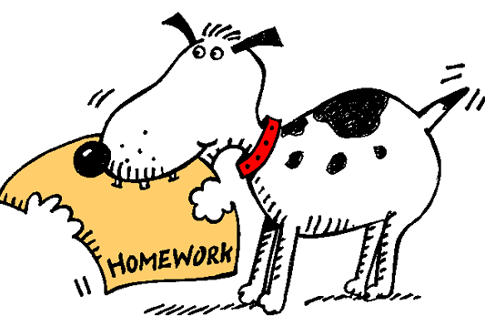

MAKE-UP WORK
The make-up of all work is mandatory, and it shall be the responsibility of the student or parent/guardian to contact the class instructor or school in order to arrange to make up work missed. Make-up work will be assigned and completed at the teacher’s discretion...
A student must make up assigned work within two consecutive days after a single day’s absence. For two or more days of consecutive absence, the student has up to five consecutive days, including weekends, to complete assignments. In extreme cases, an extension of time may be granted by the Principal.
There may be no withholding of any credit and/or grades for absences unless the student, after being given an opportunity to make up work, fails to do so.
PROMOTION AND GRADES
Decisions to promote or retain a child must be based on academic achievement and the best interest of the child involved. Factors which relate to the best interest of the child include: prognosis for future achievement in a repeated grade, previous retentions, and chronological age.
Parents or guardians must be informed no later than February 1st of the current school year if a child’s progress indicates that retention may be necessary. Notification shall be made by written letter and may be indicated on the students report card “Danger of Retention” Parents of students who enter school (transfer) after January 1 of the current school year must be notified of a decision to retain . Building principals must be informed of the decision to retain individual students. Notification of principals shall be made prior to notification of parents.

School Wide Discipline Program
SCHOOL RULES/EXPECTATIONS
I. Follow directions
II. Talk quietly when entering or leaving
building
III. No bullying, teasing, name calling, or
cursing
IV. Keep hands, feet, food and objects to
yourself
V. Do not chew gum in the school building.
VI. Do not bring toys, trading cards, cars, or
collectibles from home
VII. Tobacco products/drugs are prohibited
on school property
VIII. No public display of affection, such as hand
holding/kissing
IX. Walk, don’t run
X. Use single file and walk on right in hallways
at all times.
XI. Do not write or mark on school/other’s
property
XII. Put trash in appropriate containers

CONSEQUENCES

First Conduct Report 1 day lunch detention
Second Conduct Report 2 days lunch detention
Third Conduct Report 3 days lunch detention
Fourth Conduct Report 1 day ISS/OSS
Fifth Conduct Report 2 days of ISS/OSS
Sixth Conduct Report 1-3 days ISS/OSS

GRADE 5
The following will occur after a student has been assigned 15 days of lunch detention:
First offense 1 day of ISS/OSS
Second offense 2 days of ISS/OSS
Third offense 1-3 days ISS/OSS
Any student who receives two conduct reports in one day will be assigned ISS, in-school suspension, for willful and repeated disruption of the learning environment. A parent conference will be requested.
ISS and OSS may be assigned whenever school authorities determine that a serious infraction of school rules has occurred. This includes willful refusal to complete school tasks, insubordination, disorderly, vicious, illegal, or immoral conduct, and violations of the Safe School Act.
Serious disruptions to the learning environment at Clay Elementary School may lead to immediate ISS/OSS for a period of one (1) to ten (10) days. Serious disruptions include:
SERIOUS CONSEQUENCES
I. Fighting
II. Stealing
III. Gambling
IV. Possession of Weapons
V. Possession of Controlled Substances
VI. Purposeful Defiance of Authority
VII. Excessive Aggression/Aggressive Acts
VIII. Willful Destruction of Property
Parents will be required to pay for school property or school materials that are willfully damaged by students.

REWARDS
Students who follow school rules will receive rewards from their classroom teacher and principal. Rewards may include written notes to parents, certificates, free time, privileges, movies, parties, etc.
SAFE SCHOOLS/WEAPONS
The Safe Schools Act was passed by the West Virginia Legislature in 1995. It mandates that a student must be expelled from school for twelve calendar months if he or she commits any of the following:
A. Possesses a firearm or other dangerous or deadly weapon on the school grounds or bus.
B. Physically assaults a school employee.
C. Sells narcotics or drugs on school grounds or at a school-sponsored event.
In addition, the bill also makes it a felony to possess a firearm or other deadly weapon at school and increases the penalty for malicious wounding or abducting students within 1,000 feet of a school.
A deadly weapon means any instrument that is designed to produce serious bodily injury or death, or is readily adaptable to such use. The term deadly weapon shall include, but is not limited to the following items: blackjacks, knives, nunchucks, false knuckles, or firearms. If a student or parent has any questions about this law, please contact the school administration.
SAFE SCHOOLS HELPLINE
1-866-723-3982
TOBACCO
West Virginia’s School Law Section 16-9A-4 prohibits the use of tobacco products in school or on school grounds. Possession and/or use of tobacco products may result in ALE assignment or suspension.

WIRELESS COMMUNICATION DEVICE POLICY (WCD)
WCD’s are devices such as cell phones, smart watches, tablets, or other digital devices. Students may possess wireless devices during school hours, on school property, during after school activities (e.g. extracurricular activities) and at school-related functions, provided that during school hours and on school vehicles the WCD’s are powered completely off(i.e., not just placed into vibrate or silent mode) and stored out of sight.
Violations of this policy may result in disciplinary actions and/or confiscation of the WCD. If the WCD is confiscated, it will be released/returned only to the student’s parent/guardian.
If a student violated the terms of this policy more than two times in a single school year, she/he may lose her/his privilege to bring a WCD to school for a designated length of time or on a permanent basis, as the circumstances may warrant.

SUBSTANCE ABUSE
The Clay County Board of Education believes that the use of prohibited substances is wrong and harmful. In accordance, the Clay County School System will not tolerate the use of prohibited substances by its students. Any student found using or in the possession of any illegal or controlled substance (except tobacco) will be dealt with in the following manner.
First Offense:
A.) Five (5) day suspension from school during which the student and at least one parent or guardian must attend and successfully complete a Substance Abuse Education program designed and delivered by the school system. Completion of the program is required pursuant to the student's returning to school. The Substance Abuse Education program will consist of an educational component with an emphasis on decision making skills and rehabilitative counseling.
B.) Scheduling and completion of a conference between the parent or guardian and school officials prior to school reentry.
C.) Five day suspension to the alternative learning center or in elementary schools- its equivalent.
D.) Denial of extracurricular activities privileges for the remainder of the school term.
Second Offense:
A.) Recommendation to the Clay County Board of Education for expulsion.
B.) Notification of appropriate law enforcement officials.
Students distributing illegal or controlled substances may, at the discretion of the school administration, be treated as second offenders. The school administration may also use its discretion to notify law enforcement officials in first offense cases.
SEXUAL HARASSMENT
Sexual harassment is a form of sex discrimination that is illegal under both Title IX of the Federal Civil Rights Act of 1964 and West Virginia Code 5-1-9 (a) (1). Clay Elementary School will not tolerate sexual harassment. To report any incident of harassment or violence, go directly to a teacher or an administrator
SUPPORT FOR PERSONALIZED LEARNING
SPL is a process based on using scientific research-based instructional strategies that are matched to individual student reading needs.
Core: Screening and Differentiated Classroom Instruction. The classroom teacher delivers scientific research-based reading instruction to all students. There are five essential reading areas that are emphasized in the core reading curriculum: phonemic awareness, phonics, fluency, vocabulary, and comprehension.
Targeted: Intervention
The teacher focuses on students who do not achieve the minimum levels of satisfactory reading performance based on screening results. At this level, students receive additional reading intervention. This instruction is recommended to be 30 minutes each day, beyond the 90-minute core reading program, to small groups of children who need help with similar skills.
Intensive: Intensive Intervention
Students receive up to an additional 30 minutes of intervention each day in addition to the general education core reading program. Instruction at level three is even more intense and explicit than at level two. Group sizes are smaller, one to three students, so that individual needs can be addressed by the interventionist.
MEDICATION POLICY
Clay County Schools’ medication policy is to ensure the safety of students who must take medicine at school. All medicine brought to school by an adult and be labeled with the student’s name, prescription name, dosage, and time of administration. All medicine brought to school must be registered. This includes over the counter medicines, such as acetaminophen and ibuprofen.
Any student who takes prescription medicine at school or any non-prescription medicine for more than 15 days must provide the school with a doctor’s order to administer the medicine. The form for this order is available at school.
All prescription or nonprescription medicines must be in the original bottle. Parent/Guardians are required to bring in the medicine and talk with the teacher or nurse about their child’s medical condition. Sending medication on the school bus is not permitted.
Any child who needs an over the counter medicine occasionally, such as acetaminophen or ibuprofen, must have a written note. This note must contain the child’s name, the name of the medicine, and the time to give the medicine. A parent/guardian must sign this note.
HEAD LICE
Parents should do a preliminary check of their child’s head at home. Parents must accept the responsibility for the health and personal hygiene of their child/children. Problems with head lice need to be addressed at home. Days missed during this time will be counted as absences. Please take time to check your child’s head and hair at home regularly. Your cooperation in this matter will be greatly appreciated.

WELLNESS CENTER
The Wellness Center is a collaborative effort between the Clay County Board of Education and Primary Care Systems, Inc. It is staffed by the county health nurses and Primary Care personnel. Primary Care can treat students only if the consent form has been signed and returned.
ARTICLES PROHIBITED IN CLASS
Items such as CD players, laser pointers, cameras, electronic equipment, Ipods, DSs’, toys and other play items should not be used or present during class time. They disrupt the learning process and are at risk of being stolen. Articles of this nature will be confiscated by the teacher and turned over to the office. Parents may make arrangements to pick up the item from the office.
SCHOOL PROPERTY
Students are responsible for the proper use and care of all school property. Students who vandalize school property or equipment will be required to clean and pay for the damage, replace the item, and may lead to disciplinary action.
TEXTBOOKS
Textbooks are the property of Clay County Schools and are for student use during the school year. Students are responsible for any lost or damaged textbooks or library books. Additional books will not be issued until previous book fines or replacement costs have been paid.
ESSA -Every Student Succeeds
The ESSA Plan will include:
Academic Standards and Assessment:
challenging academic standards for all students

School Accountability and Support for Improvement:
a school accountability system which must include various indicators of student achievement and outcomes and a system of support for improving schools

Support for Excellent Educators:
strategies for recruiting and retaining highly effective educators, providing supports to improve educator effectiveness and assuring that all student have access to highly effective teachers

Support for All Students:
ensure that all students receive a fair, equitable and high quality education with a focus on specific subgroup interventions.

Support for Excellent Educators:
strategies for recruiting and retaining highly effective educators, providing supports to improve educator effectiveness and assuring that all student have access to highly effective teachers.

Support for All Students:
ensure that all students receive a fair, equitable and high quality education with a focus on specific subgroup interventions.
PHYSICAL EDUCATION
Clay Elementary Students in grades K-5 are required to have physical education class three days per week. Each child is required to wear tennis shoes or soft-soled shoes during physical education classes. For safety reason, open-toed shoes, platforms, or heeled shoes will not be permitted. Wearing of improper shoes may make it impossible for a student to meet the West Virginia Content Standards and Objectives of the physical education program.
Any student who cannot participate in physical education due to injury or illness must bring a note from a parent/guardian or a doctor’s excuse. For exemptions of more than two days, a doctor’s excuse is required.
Clay Elementary PAX GBG
The PAX Good Behavior Game® is a powerful evidence-based practice, consisting of proven instructional and behavioral health strategies used daily by teachers and students in the classroom. This universal preventive approach not only improves classroom behavior and academics, but also provides a lifetime of benefits for every child by improving self-regulation and co-regulation with peers.
- PAX Improves classroom performance
- Improves mental health outcomes
- Improves substance use prevention
Students in PAX Classrooms will demonstrate-
- improved scores on Math and Reading assessments
- higher reading levels than their peers
- reduced need for Special Needs Services
- higher graduation and college entrance rates
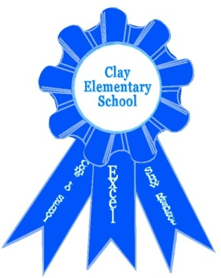
TITLE 1 COMPACT
Clay Elementary School and the parents of the students participating in activities, services, and programs funded by Title 1, Part A of the Elementary and Secondary Education Act agree that this compact outlines how the parents, school staff, and students will share the responsibility for improved student academic achievement and the means by which they will develop a partnership that will help children achieve the State’s high standards.
SCHOOL REPSONSIBLITIES: Clay Elementary School will:
1. Provide high-quality curriculum and instruction in a supportive and effective learning environment by use of a focused instructional and assessment programs emphasizing individual instruction, time on task, teacher-parent communication, and improved student self-concept and peer relationships. 2. Provide parents reasonable access to staff by means of arranged conferences with school administrators or teachers. Appointments with teachers must be scheduled during teacher’s planning period. 3. Hold parent-teacher conferences during which this compact will be discussed as it relates to the individual child’s achievement.
Parent-teacher conferences will be scheduled as follows:
Tuesday, October 25, 2022
Tuesday, February 7, 2023
4. Provide frequent progress reports
1st Grading period 08/23/22 – 10/21/22
1st Progress Report Tuesday 09/20/22
1st Report card Tuesday 10/25/22
2nd Grading Period 10/24/22 – 01/12/23
2nd Progress Report Tuesday 11/29/22
2nd Report Card Tuesday 01/17/23
3rd Grading Period 01/13/23 – 03/24/23
3rd Progress Report Tuesday 02/14/23
3rd Report Card Tuesday 03/28/23
4th Grading Period 03/27/23 – 05/26/23
4th Progress Report Tuesday 04/25/23
4th Report Card 05/26/23
GRADING SCALE A: 90-100 Superior
B: 80-89 Above Average
C: 70-79 Average
D: 60-69 Below Average
F: 0-59 Unsatisfactory
5. Provide parents opportunities to volunteer and participate in their child’s class and to observe classroom activities during holiday parties, school assemblies, competitions, carnivals, and Students of the Month luncheons. Parents are also encouraged to meet with teachers during their planning time to arrange classroom visits.
PARENT RESPONSIBILITIES:
1. Monitoring attendance
2. Monitoring assignment completion
3. Communicating with the school
4. Serving on policy advisory groups
5. Participating in decisions relating to the
child’s education
