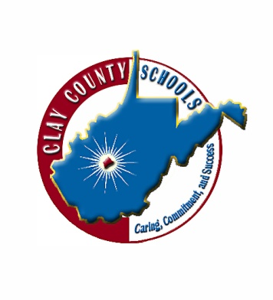 

**C L A Y C O U N T Y S C H O O L S**



**P.O. Box 120 ● 285 Church Street ● Clay, West Virginia 25043**

**Telephone (304) 587-4266 ● Fax (304) 587-4181 ● www.claycountyschools.org**

# BOARD OF EDUCATION

Joe Paxton, Superintendent Susan Bodkins Brooke Jones

Phoebe Nichols

Lolita Nutter David Pierson

TO: Clay Elementary School Parents

FROM: Michelle Paxton, Clay Elementary School Principal

SUBJECT: PARENTS RIGHT-TO-KNOW

DATE: August 23, 2022

We are looking forward to working with you and your child this school year. As a parent of a student at Clay Elementary School, you have the right to know the professional qualifications of the classroom teachers who instruct your child. Federal law allows you to ask for certain information about your child’s classroom teachers and requires us to give you this information in a timely manner if you ask for it. Specifically, you have the right to ask for the following information about each of your child’s classroom teachers:

■ Whether the West Virginia Department of Education has licensed or qualified the teacher for the grades and subjects he or she teaches.

■ Whether the West Virginia Department of Education has decided that the teacher can teach in a classroom without being licensed or qualified under state regulations because of special circumstances.

■ The teacher’s college major; whether the teacher has any advanced degrees and, if so, the subject of the degrees.

■ Whether any teachers’ aides or similar paraprofessionals provide services to your child and, if they do, their qualifications.

Should you request the information above from the school principal, you will receive a timely reply. Thank you for your time and cooperation. Also, please remember that, as a parent, you are especially important to us and you are always welcome at Clay Elementary School.